Unit 2: Solving Equations

Lesson 3: Literal Equations

Objectives:

- Students can investigate a problem that involves Literal equations and create an equation in one variable to solve it.
- Students can investigate a problem that involves consecutive integers and create an equation in one variable to solve it.

Agenda:
- Warm up
- Quiz
- Class Discovery: Literal Equations
- Practice:

Vocabulary:

- Literal equations, Consecutive integers, Odd and Even integers.

Focus Questions:

- How can I solve Literal equations in real-life problems?
- How can we express consecutive, even, odd integers?

For your entertainment:
http://www.regentsprep.org/regents/math/algebra/AE4/litPrac.htm
http://www.quia.com/cz/43436.html?AP_rand=1776803402

Homework: HW2-3

Literal Equations: A literal equation is an equation where variables represent known values. Literal equations allow use to represent things like distance, time, interest, and slope as variables in an equation.

Warm up: Solving equations

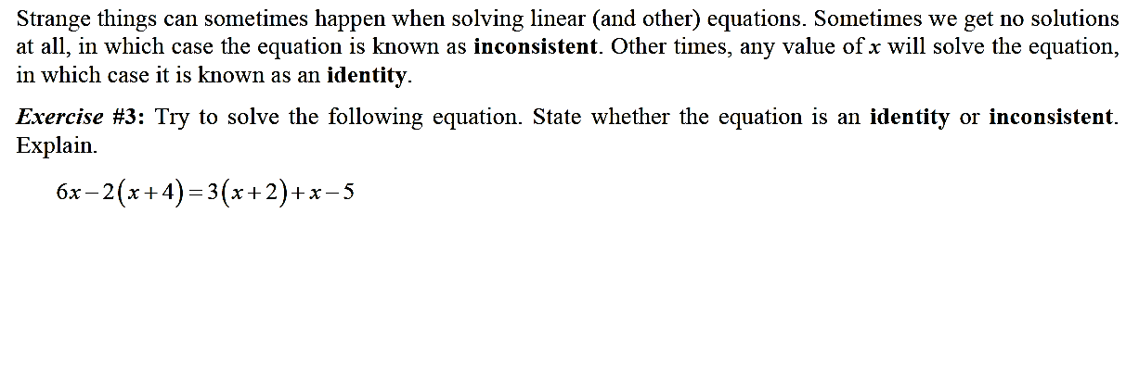

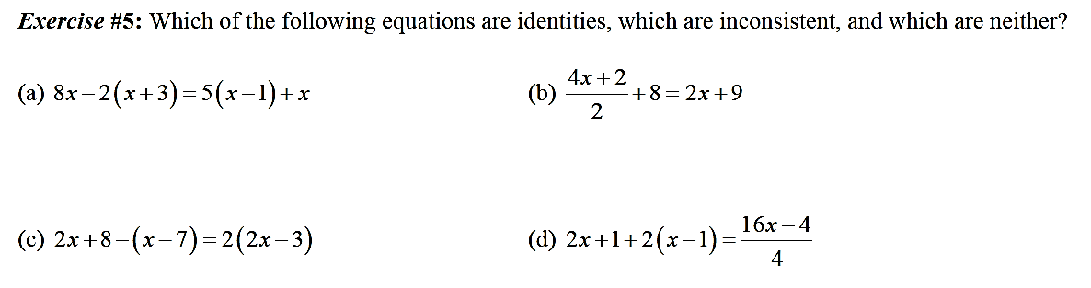

Solving Equations with variables in.
https://www.youtube.com/watch?v=gqSfw2gmMsghttps:

Write down the examples and solutions: (At least 2)

Time to practice:
1] Solve for h in terms of v

$v=\frac{1}{3}h$

Solve for p in terms of A, r and t.
2]$A=2P+rt$ 3] 2A = 3P – 2rt

Literal equations: Continue
- Solve for p:  $$\frac{1}{3}(p-4)=n$$ | - Solve for r :  $V= π r^{2}h$
- Solve for h:  $V= π r^{2}h$ | - Solve for B:  $$V=\frac{1}{3}Bh$$
- Solve for r in terms of A, P and t.  $A=P+rt$ | 6.Solve for (v) in terms of K and m  $K=\frac{1}{2}mv^{2}$
7.solve for y in terms of x:  2Y – 5x = 10 | 8. Solve for y in terms of x  $x=\frac{1}{2}y+6$

8 Students were asked to write a formula for the length of a rectangle by using the formula for its perimeter, . Three of their responses are shown below.  I. 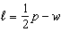  II. 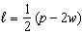  III. 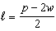 | Which responses are correct?  1) I and II, only  2) II and III, only  3) I and III, only  4) I, II, and III

Name : _________________ Date:
Algebra 1– Homework 2-3

- Solve for x: 2)

3) Boyle's Law involves the pressure and volume of gas in a container. It can be represented by the formula . When the formula is solved for , the result is
1)
2) | 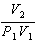
3) | 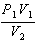
4) | 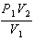

4) Michael borrows money from his uncle, who is charging him simple interest using the formula . To figure out what the interest rate, r, is, Michael rearranges the formula to find r. His new formula is r equals
1) | 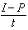
2) | 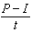
3)
4)

5) The equation for the volume of a cylinder is . The positive value of r, in terms of h and V, is
1) | 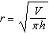
2)
3)
4) | 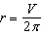

6) The formula for electrical power, P, is , where I is current and R is resistance. The formula for I in terms of P and R is
1) | 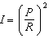
2) | 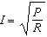
3)
4)

7) The formula for blood flow rate is given by 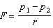, where F is the flow rate, the initial pressure, the final pressure, and r the resistance created by blood vessel size. Which formula can not be derived from the given formula?
1)
2)
3)
4) | 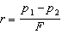

8) Solve for y.

